Pete the Cat-I Love my White Shoes
Print out handouts and get materials ready
Show sign language for Shoes and Cat
Show the Video of the Read Aloud on YouTube
Do the activities1 and 2
Show the Video of The Groovy Song- Pete goes Marching On
Color the white shoe
ENJOY!
Activity 1- Groups of 4 Shoes
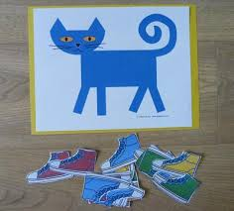
What you need: Pete the Cat Mat printable, Shoes printables, Zip lock bag Skill: Counting, number 4
What you do: Print Pete the Cat Mat and Shoes printables Cut out each shoe and place in a zip lock bag.
Discuss with children how many shoes Pete the Cat was wearing (4). Demonstrate to children how they can dress up Pete the Cat with different shoes. Encourage children to tell you about the color and number of shoes Pete the Cat is wearing. Example: Pete the Cat is wearing one blue shoe and three red shoes.
Addition: Place one red shoe on the Pete the Cat Mat. Ask, "How many shoes does Pete need to put on? (3) Yes, one red shoe and three blue shoes make 4."
Activity 2- Pete the Cat: Counting Whiskers
What you need: Blue paper or plastic plate, Yellow craft paper, White craft paper, Blue play dough, Colored pom-poms, Pipe cleaners cut in pieces, Small container, Glue,
Cut Pete the Cat face on a piece of craft paper. Cut the pipe cleaners in to three pieces. Place the pipe cleaners and the play dough in small containers. Instructions: First, let children form two big balls out of the blue play dough and place them side by side below the nose. Have fun adding whiskers in the playdough and counting!

