admin

**GiGi's Playhouse Rockford Down Syndrome Achievement Center**

*“At this very moment, somewhere in America, parents are getting the unexpected news that their baby has Down syndrome. Ten years ago, I never expected to be that mother. I was shocked, scared, uneducated and alone. I am proud to be a part of the social revolution that is changing all of that, GiGi’s Playhouse.”*

*-Meg Christofferson, now the proud parent of two children with Down syndrome*

GiGi’s Playhouse Rockford 8801 N. Second St Machesney Park, IL 61115 815-654-7529 (PLAY)

[www.gigisplayhouse.org/rockford](http://www.gigisplayhouse.org/rockford)

**\*be kind *be generous *be accepting**



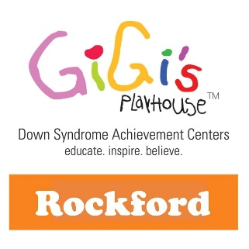

GiGi’s Playhouse Rockford presents in 2019:

“I have a Voice” Gala-May 31 No Limits Run/Walk-June 22

“No Bull” Golf Play Day-Sept. 9

Benefiting children and adults with Down syndrome

While serving nearly 375 families in a five-county region, GiGi’s Playhouse Rockford makes a lifetime commitment to

offer support from diagnosis to adulthood, to build confidence, and to send a global message of acceptance for all while changing the way the world sees Down syndrome. We offer therapeutic, educational, and career training programs FREE of charge so cost is never a barrier to participation or achievement. All programs, available to all age groups, are based on GiGi’s Playhouse core value “Best of All” – always looking to improve in everything we do, always celebrated and never ending.

**Because of a lack of understanding and fear, approximately 85% of Down syndrome pregnancies are terminated.**

**Down syndrome is the largest chromosomal disorder in the U.S., but it is the least funded.**

**There are over 450,000 individuals with Down syndrome in the United States.**

**Our core message is Global Acceptance for everyone, which we live out every day by celebrating the achievements**

**of individuals with Down syndrome through programs, special events, and critical social change campaigns.** With that said, programs are not free to deliver. To continue changing outdated perceptions and enrich the quality of many more lives, we need funding for programs and campaigns which will affect today’s and tomorrow’s generations.





**We are EXCITED to announce all the opportunities available to help make a meaningful impact in our community.**

We have many opportunities for organizations to help us meet our mission*:* ***Inspire and empower individuals with Down syndrome to succeed in life.*** At GiGi’s Playhouse, our programs provide crucial

physical, occupational, developmental, and speech therapy. We also offer FREE tutoring in literacy and math to ensure success in school, using best practices that maximize learning for our kids.

Our three major fundraising events are very important to the survival of our Playhouse. They are the key to expanding our voice in our community and give us an opportunity to celebrate achievements and continue to change the way people view Down syndrome.

GiGi’s Playhouse Rockford 8801 N. Second St Machesney Park, IL 61115 815-654-7529 (PLAY)

[www.gigisplayhouse.org/rockford](http://www.gigisplayhouse.org/rockford)

**\*be kind *be generous *be accepting**

**You can be a true hero in the lives of children and adults with Down syndrome by supporting one of our 2019 fund**

**raising events as a sponsor or impact partner.** Because of your generosity, more individuals WILL learn to read, improve their health and wellness, develop career skills, and live truly beautiful lives. More communities will embrace individuals with Down syndrome as equals and friends. Miracles do happen at GiGi's Playhouse Rockford, where we turn belief into achievement. Thank you for your consideration, and for believing in our individuals and families!



GiGi’s Playhouse Rockford presents in 2019:

“I have a Voice” Gala-May 31 No Limits Run/Walk-June 22

“No Bull” Golf Play Day-Sept.9

Benefiting children and adults with Down syndrome

**GiGi’s Playhouse exists today through the continued outpouring of generous donations from our corporate community and the efforts of selfless volunteers. GiGi’s Playhouse programs cover the full lifespan of the individual, starting from prenatal diagnosis and continuing into adulthood.**

**These lifetime services are always offered 100% free of charge for our participants and their families.**

**For more information on GiGi’s Playhouse Rockford, please visit** [***www.gigisplayhouse.org/rockford***](http://www.gigisplayhouse.org/rockford)

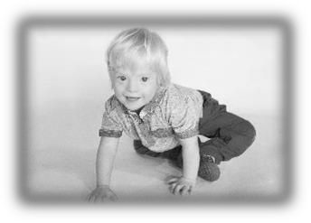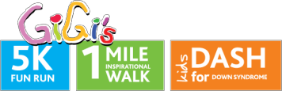



GiGi’s Playhouse Rockford presents in 2019:

“I have a Voice” Gala-May 31 No Limits Run/Walk-June 22

“No Bull” Golf Play Day-Sept.9

Benefiting children and adults with Down syndrome

**Jogger ($250+)**

**Racer ($500+)**

* Verbal recognition from stage on race day

NO LIMITS 5K RUN/1 MILE WALK/DASH FOR DOWN SYNDROME/FAMILY FEST

June 22, 2019

Rock Valley College

At GiGi’s Playhouse, our mission is to inspire and empower individuals with Down syndrome to succeed in life. Dreams, hopes, and plans are the driving force behind GiGi’s Playhouse Rockford. We set high expectations and encourage all our participants to be their “Best of All.” There are NO LIMITS to what they can achieve. We hope that you will join us in motivating others to reach beyond their limits. Show that you care and that you want to encourage everyone’s dreams and aspirations in life.



**Champion ($2,500+)**

•

•

•

•

•

•

•

•

•

Top billing in all media advisories/releases and promotional efforts

Recognition on banners at start/finish Speaking opportunity from stage on race day

Three exclusive recognitions on GiGi’s Playhouse Rockford’s Facebook page Exclusive sponsorship of two or more water stations along race route

Logo on Facebook header image promoting the event

Logo on e-mail header image promoting event (3,000 + recipients) Logo/mention in thank you e-mail to GiGi’s Playhouse supporters after event Logo on t-shirts

**Sprinter ($1,000+)**

•

•

•

•

•

•

Two exclusive recognitions on our Facebook page

Exclusive sponsorship of one water station along race route Logo on our Facebook header image promoting the event

Logo on our e-mail header image promoting the event (3,000 + recipients) Opportunity to display company banner

Logo on t-shirt

•

•

•

•

•

Name (text only) on GiGi’s website

Name (text only) on t-shirts & posters Name (text only) in e-mails promoting race Recognition at start of the race

Name on t-shirt

•

•

•

Opportunity to distribute promotional materials

Name recognition (text only) on the GiGi’s website

Name (text only) on t-shirt

GiGi’s Playhouse Rockford 8801 N. Second St Machesney Park, IL 61115 815-654-7529 (PLAY)

[www.gigisplayhouse.org/rockford](http://www.gigisplayhouse.org/rockford)

**\*be kind *be generous *be accepting**

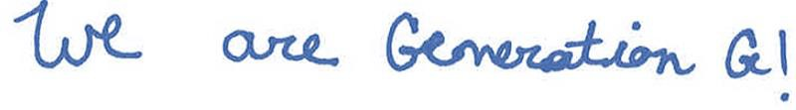

Please return this form along with your donation. Specific dimensions for Sponsorship Advertisements are on the attached page for each level.



2019 Sponsorship Donation Form – THANK YOU!

□ Individual name

GiGi’s Playhouse Rockford presents in 2019:

“I have a Voice” Gala-May 31 No Limits Run/Walk-June 22

“No Bull” Golf Play Day-Sept.9

Benefiting children and adults with Down syndrome

GiGi’s Playhouse is a 501(c) 3 nonprofit organization funded solely by the generosity of our donors.

FEIN # 27-2251844. Donations are tax deductible to the fullest extent of the law. If paying by check, please mail payment to:



Do you prefer to be recognized by:

□ Company name

□ Anonymous

Company/Individual Name:

Contact Name:

Address:

City: State: Zip:

Telephone:

Email address: _

Website/URL:

Event: Gala

Golf

5K Run/Walk

Sponsorship Level:

GiGi’s Playhouse Rockford

Attention: Karen Carlson 8801 N. Second St.

Machesney Park, IL 61115

GiGi’s Playhouse Rockford 8801 N. Second St Machesney Park, IL 61115 815-654-7529 (PLAY)

[www.gigisplayhouse.org/rockford](http://www.gigisplayhouse.org/rockford)

**\*be kind *be generous *be accepting**





GiGi’s Playhouse Rockford presents in 2019:

“I have a Voice” Gala-May 31 No Limits Run/Walk-June 22

“No Bull” Golf Play Day-Sept.9

Benefiting children and adults with Down syndrome

**In-Kind Donation Form – THANK YOU!**

Date Item Physically Acquired:

Name of Person Acquiring Item: Location of Item:

**For Office Use Only:**



**Please complete a separate form for each donation.**

Do you prefer to be recognized by:

□company name

□individual name

□anonymous

Company/Individual Name:

Contact Name:

Address:

City: State: Zip:

Telephone:

Email address:

Website/URL:

Description of Item Donated:

Value of Item Donated: $

Good

Service

Name of Donor(s) to be listed in Program Book (if different than above):

Instructions for acquiring Item: _

Any restrictions on use:

GiGi’s Playhouse Rockford 8801 N. Second St Machesney Park, IL 61115 815-654-7529 (PLAY)

[www.gigisplayhouse.org/rockford](http://www.gigisplayhouse.org/rockford)

**\*be kind *be generous *be accepting**

Gala

Golf

G-Force 5K