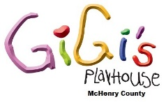
Support GiGi’s Playhouse McHenry County with a
“DOWN RIGHT Awesome” t-shirt

Wear this original T-Shirt around town with pride. Stylish with a message
that everyone will understand!

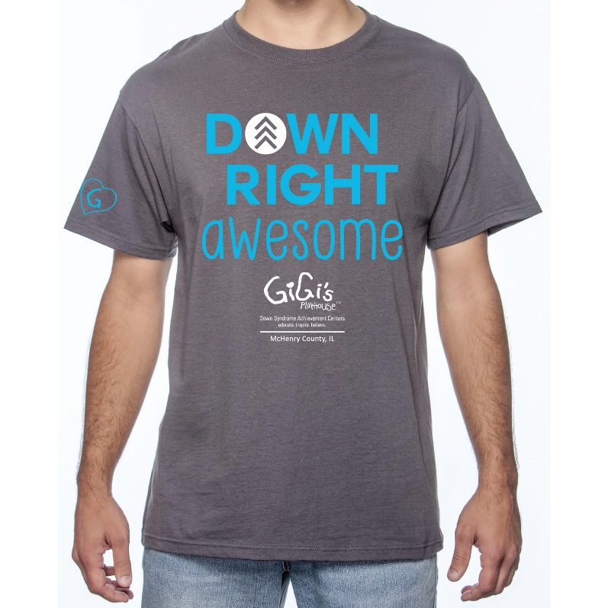

Buy your t-shirts today! Perfect for yourself, family and friends.

T-Shirt: $12.00

Orders can be picked up at the Fashion Show Luncheon on April 19, 2020 or at the Playhouse.

GiGi’s Playhouse McHenry County T-Shirt
Order Form

Sizes: Youth x-small - Youth large
Adult small - Adult 5X
$12.00

Quantity | Size  (Specify Youth or Adult) | Price | Total

Total quantity _____________

Total payment _____________

Name: _____________________________________________________________________________
Address: __________________________________________________________________________
City: _________________________________ State: _____ Zip: ____________
Telephone: ______________________ Email address: _____________________________________

Must be paid for by check or cash only if mailing us your payment. Mail order form with payment to:

GiGi’s Playhouse McHenry County
5404 W Elm St. Suite A
McHenry, IL 60050

I will pick up my order at the Playhouse.
I will pick up my order at the Fashion Show.

